Expt 3 . System Calls: Fork, Exit, Getpid, Wait, Close:
PROGRAM 1: FORK(), GETPID(), WAIT(), EXIT()
C PROGRAM
#include<stdio.h>
#include<stdlib.h>
#include<unistd.h>
#include<sys/wait.h>
int main() {
pid_t pid;
pid = fork();
if(pid < 0) {
printf("Fork Failed\n");
exit(1); }
else if(pid == 0) {
printf("\nCHILD PROCESS");
printf("\nChild PID : %d", getpid());
printf("\nParent PID : %d\n", getppid());
exit(0); }
else {
wait(NULL);
printf("\nPARENT PROCESS");
printf("\nParent PID : %d", getpid());
printf("\nParent's Parent PID : %d\n", getppid()); }
return 0; }
Output: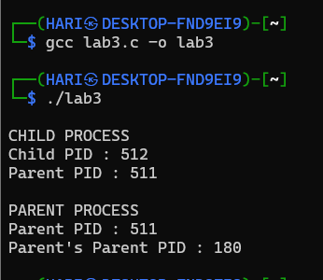
Shell program :
#!/bin/bash echo
"Parent Process ID : $$"
( echo "Child Process ID : $$"
echo "Parent Process ID : $PPID"
exit 0 ) &
wait
echo "Child Process Completed"
Output :
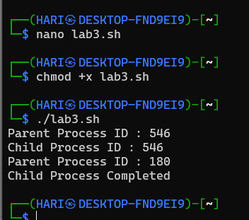
PROGRAM 2:
WAIT() SYSTEM CALL
C PROGRAM
#include #include #include
int main() {
pid_t pid;
pid = fork();
if(pid == 0) {
printf("Child Process Running\n");
sleep(5);
printf("Child Process Completed\n"); }
else {
wait(NULL);
printf("Parent Resumes Execution\n"); }
return 0; }
Output:
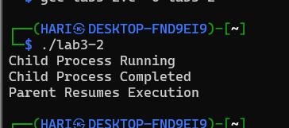
SHELL SCRIPT
#!/bin/bash
( echo "Child Process Running"
sleep 5
echo "Child Process Completed" ) &
wait
echo "Parent Resumes Execution"
Output:
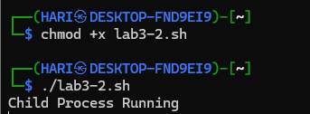

PROGRAM 3:
CLOSE() SYSTEM CALL
C PROGRAM
#include<stdio.h>
#include<fentl.h>
#include<unistd.h>
int main() {
int fd;
fd = open("sample.txt", O_RDONLY);
if(fd < 0) {
printf("File Opening Failed\n");
return 1; }
printf("File Opened Successfully\n");
close(fd);
printf("File Closed Successfully\n");
return 0; }
Output:
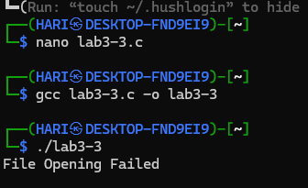
Shell program:
#!/bin/bash
exec 3< sample.txt
echo "File Opened Successfully"
exec 3<&-
echo "File Closed Successfully"
Output:
